Cindy Khuu & Rebecca Karunakaran

IST 687

# Introduction

## **Scope/Context of this analysis**

For our project, we have chosen a data set that has 120 years of historical data on the Olympic games including the athletes that have participated in either the summer or the winter Olympics. The goal of this project is to explore and identify patterns in the history of the Olympics. By examining the data, we will be able to understand how each nation participated in each event and sport, how female athlete’s participation changed over time, and who won medals. This will help us understand the significance of the Olympics over time and enable us to make predictions on the winners for the next summer Olympics in Tokyo (2020).

For this project we have decided to limit the scope to the Summer Olympics only from 1986 to 2016. The columns available about each athlete are Unique ID of Athlete, Athlete Name, Sex, Age, Height (cm), Weight (kg), Team Name, National Olympic Committee, Games, Year, Season, Host City, Sport, Event, and Medal.

## **High level background**

The modern Olympics is the largest international sporting event, founded in 1894 by Baron Pierre de Coubertin, a French educationist who wanted to revive the ancient Olympic Games to foster peace amongst different nations, people, faith, and culture. The first modern Olympics occurred in Athens, Greece in 1896 with 14 nations, and the event has largely grown in participation since then. Today, there is over 200 nations participating in the Olympics.

Every four years, the Olympic Games is held. The Olympics features summer and winter sports. The first Summer Olympics was hosted in 1896, and then Winter Olympics was formed with the popularity of winter sports and first hosted in 1924. Even with the Olympic Movement during the 20th and 21st century, it also had a large role in world history such as allowing women to compete in 1900, shifting of from amateur athletes to professional athletes, and enduring boycotts and cancellations of the event during wars.

With over 120 years of existence as a leading international event, the Olympic Games has truly touched many nations and provided an event where different nations, people, culture, and faith can come together to compete and celebrate the games.

# Business Questions

Below is a list of questions we would like to answer as we explore the dataset in order to get a better context and insights of the Olympics.

* How did different nations perform and participate?
* How did different genders perform and participate?
* How different was the participation in the different sports and events?
* Top 5 countries to win medals in the last 10 Olympic games
* Who was the youngest/oldest person to ever participate?
* Which nation has the most participants and which year?
* Who was the shortest/ tallest athlete?
* Which athlete has won the most Olympic medals?
* Correlation of Age to success?
* Correlation of Height/Weight to success?
* Top 5 cities to host the Olympics most
* Can we predict who will win the next event?

# Data Acquisition, Cleansing, Transformation, Munging

## **Data Acquisition Process**

After review multiple websites for potential datasets for our project we decided to choose the we decided on the “Olympic Athletes and Events” Dataset from “Kaggle” <https://www.kaggle.com/datasets> which is a well- known competition platform for predictive modeling and analytics. Being huge fans of the Olympic Games, this dataset promised to be an interesting one to perform data-mining as well as do some predictive analysis for future games.

## **Data Selection**

We were able to download the CSV file from the website which contained information on athletes for both the summer and winter Olympics but we have decided to focus on the data for the “Summer” Olympics only.

## **Data Quality Assessment**

Using the head() and str() function, we were able to review the data, and fortunately found it to not have unwanted columns or rows - very clean dataset. The only exception would be some NA values under Height, Weight, and Age. We decided to replace the NA in these variables with the respective means.

* Understand the structure of the data

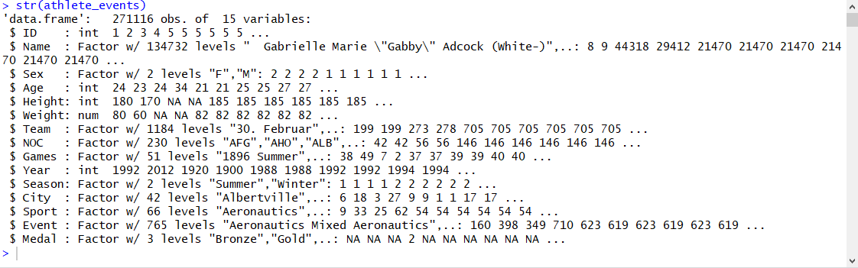

* Examine the data

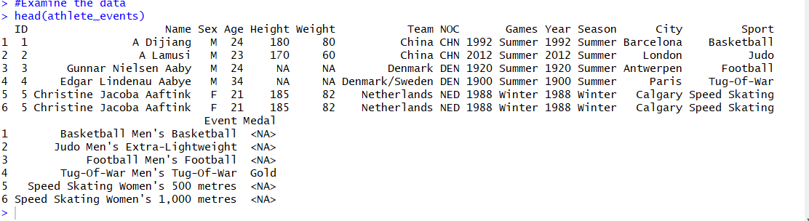

* Data cleansing by replacing NA with means for Age, Height, and Weight. Then, validated using summary()

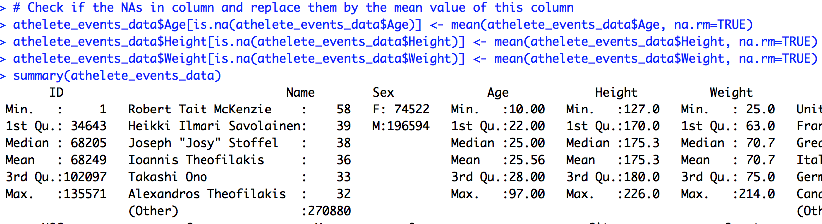

## **Variable Selection**

Key fields we will be using to explore the dataset and answer business questions are: *Name, Sex, Age, Height, Weight, NOC, Team, Year, Season, Event, and Medal.*

## **Data Dictionary**

|  |  |  |  |
| --- | --- | --- | --- |
| **Column** | **Data Type** | **Description** | **Sample Data** |
| ID | integer | Unique number for each athlete | 9 |
| Name | char | Athlete's name | Antti Sami Aalto |
| Sex | char | M or F | M' or 'F' |
| Age | integer | Athlete's Age | 30 |
| Height | integer | Athlete's height in centimeters | 172 |
| Weight | number | Athlete's weight in kilograms | 55.5 |
| Team | char | Team name | United States |
| NOC | char | National Olympic Committee 3-letter code; Represents their nation | USA |
| Games | char | Year and season | 2002 Winter |
| Year | integer | Year | 2002 |
| Season | char | Summer or Winter | Winter |
| City | char | Host city | Salt Lake City |
| Sport | char | Sport | Ice Hockey |
| Event | char | Event | Ice Hockey Men's Ice Hockey |
| Medal | char | Gold, Silver, Bronze, or NA | Gold |

# Exploring the Dataset

## **Descriptive Statistics**

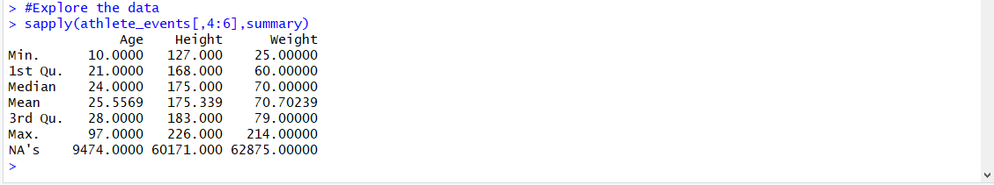

### **Players by Nation**

USA, Great Britain, and France have the top number of athlete participants. These countries have had the longest participation since the first games.

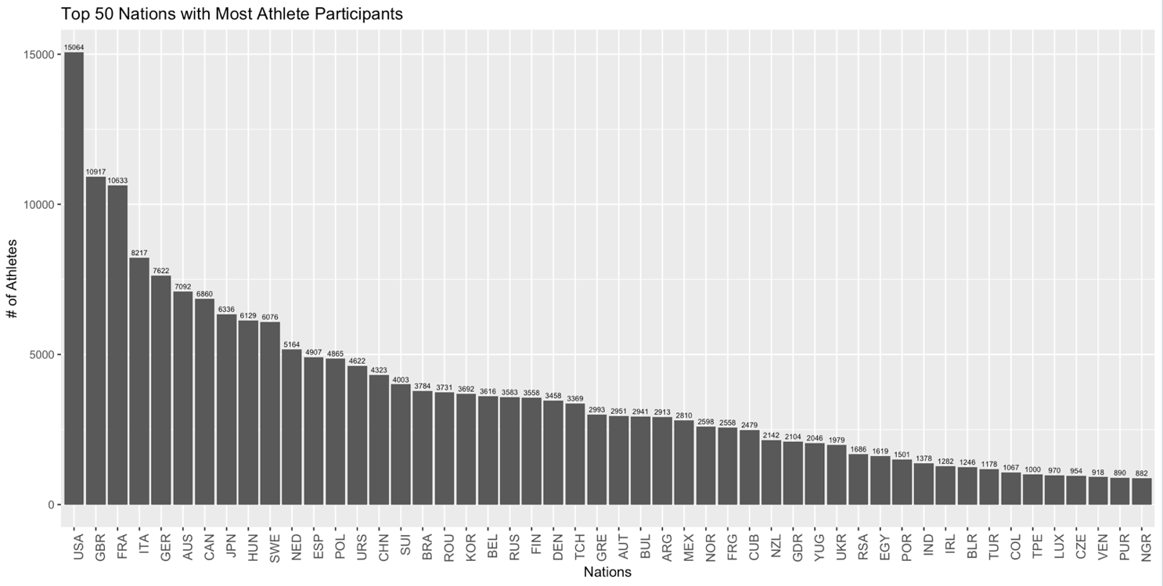

### **Medals by Nation**

USA, Soviet Union, and Great Britain are the top 3 medal winning countries.



### **Players by Gender**

Males have dominated the games with the most participants compared to Female. Looking at Female participation over time, they did not start participating until the 1900 when they were first allowed to participate. This participation has increased over time, becoming almost equivalent as to Males.

|  |
| --- |
|  |

### **Medal Count by Age Group**

Medal Count peaks around the 21-25 Age Group for both male and female athletes

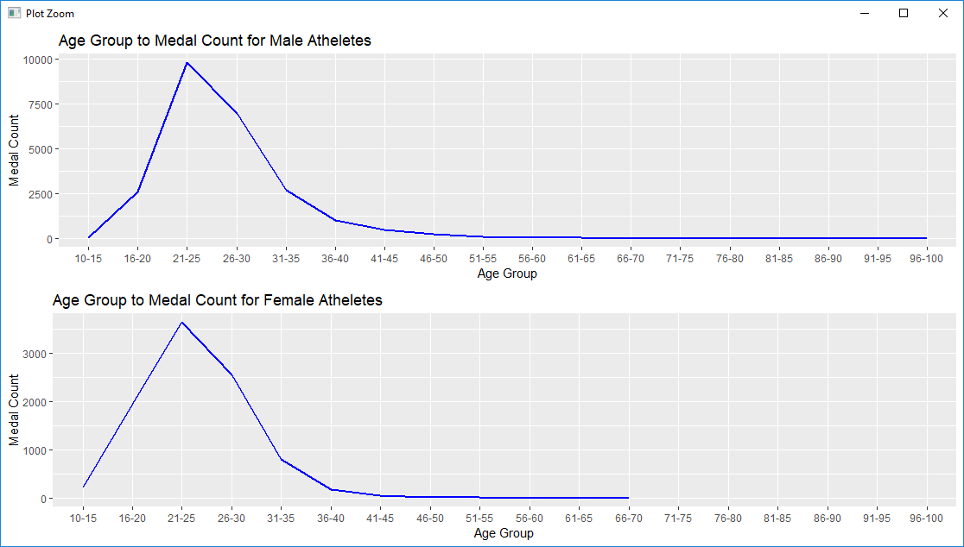

### **Medal Count by Height/Weight**

Looking at these charts we see that there the ideal height for both male and female athletes to win medals is around 175 cm and ideal weight is around 70kgs.

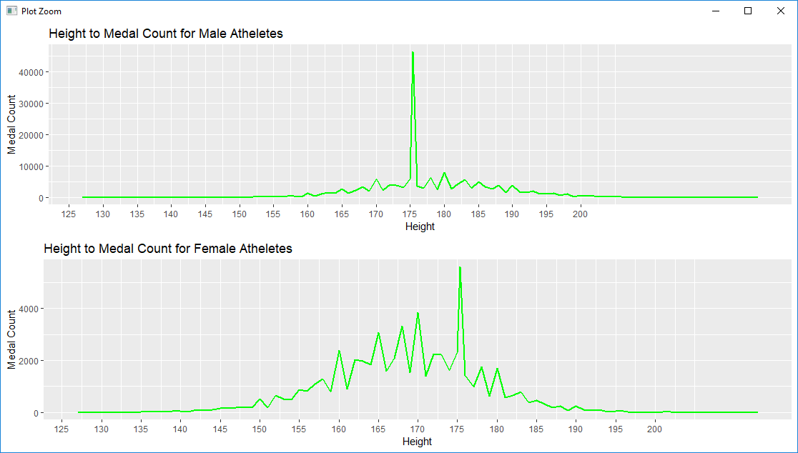

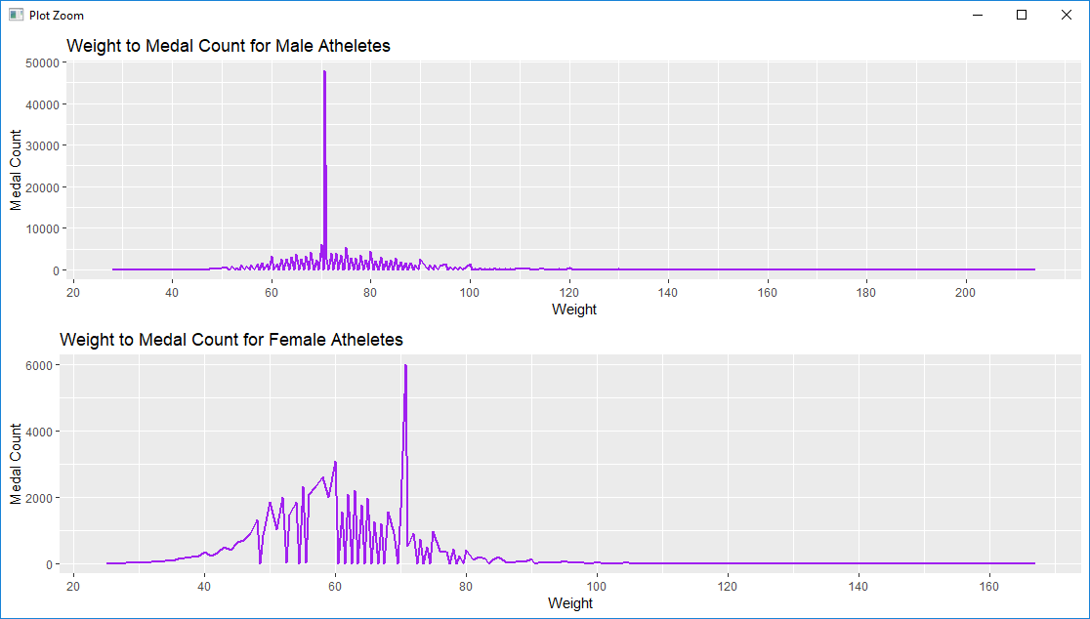

### **Top 5 cities that have hosted the Olympics the most**

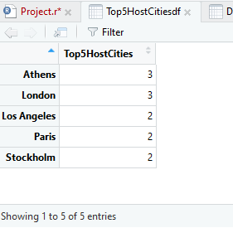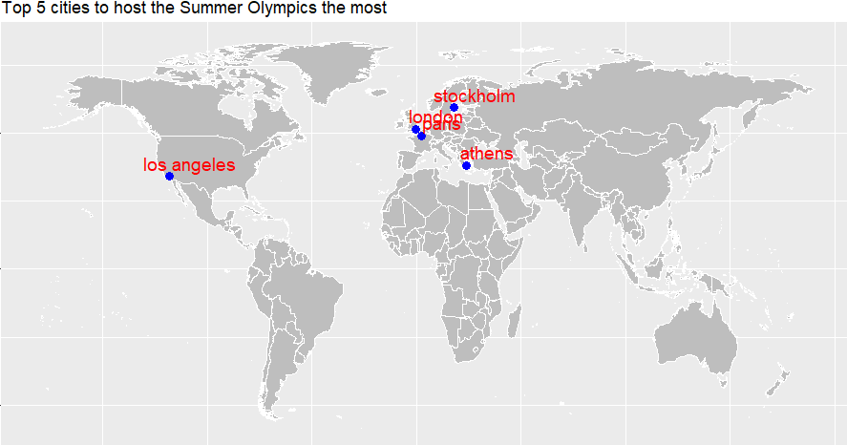

### **Correlations**

There are three numerical variables in our dataset: Age, Height, and Weight. Typically, these three variables have some kind of influence on performance. Intuitively, we would want to add these to our models later in order to predict if gold medal wins. Prior to adding it to our model later, we want to understand if these variables are correlated. If they are, we would need to decide to combine the correlated variables or choose one of the variables that are correlated.

Below shows a correlation matrix of Age, Height, and Weight. We can see that Age and Height and Age and Weight have positive, but weak correlations. In contrast, Height and Weight have a strong positive correlation of .785. Usually, the taller you are the more you would weigh due to body mass. Therefore, this correlation makes sense and seems to be valid. In our modeling section, we will end up combining Height and Weight into one variable, which eliminates multicollinearity in our model.

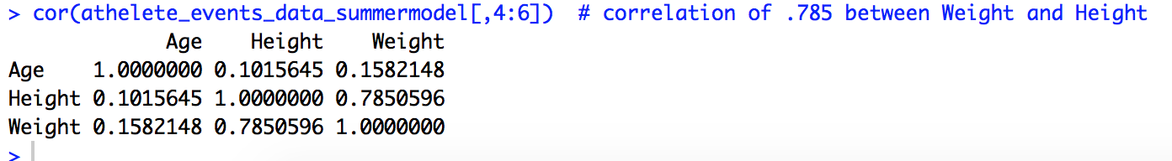

# Interesting Findings

### **Who was the youngest/oldest person to ever participate?**

### The youngest participant in the history of the summer Olympics was Dimitrios Loudras who was 10 in 1896. The oldest participant in the history of the summer Olympics Adams Ward who was 97 in 1896

### 

### **Which nation has the most participants and which year?**

### The nation that had the most participants in the history of the summer Olympics was the United States in 1996 with 827 athletes

### 

### **Who was the shortest/ tallest athlete?**

### The shortest participant in the history of the summer Olympic was Rosario Briones who was 127 cms. The tallest participant in the history of the summer Olympic was Yao Ming who was 226 cms.

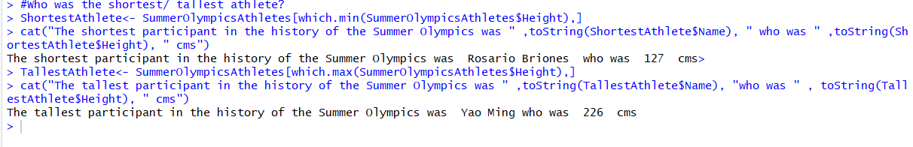

### **Which athlete has won the most Olympic medals?**

### The athlete that has won the most medals in the summer Olympic is Michael Fred Phelps, II with 28 medals

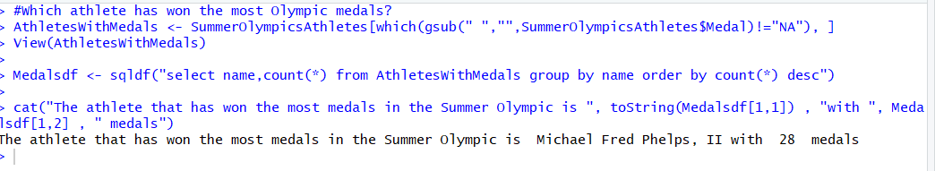

# Use of Modeling Techniques

### **Method for Predicting Who Will Win**

Our goal is to predict who will win the next Olympic event based on the attributes given to us in our dataset. In order to predict who will win the next event, we need to predict which Nation will with the most gold medals. The nation that wins the most gold medals is usually known as the most recognized winner of the event. Since our data represents each athlete that participated in the Olympics, we will need to predict if each athlete will win a gold medal or not based on identified attributes to include in our model. After predicting who will win or not win a gold medal, we will calculate the total gold medals won by each nation to identify who is the winner of the event.

### **Variable Selection for Modeling**

After exploring the dataset, we identified common attributes that appear to have some relation and impact to the number of medals won. We noticed Age, Sex, and the type of Nation with the number of medals won, which is why we have selected these variables into our model.

In addition, intuitively, we understand that height and weight have an impact to an athlete’s performance, as they have to train, condition, and maintain body measurement. Also considering Age, Sex, Nation, Height, and Weight, certain aspect of these can be an advantage in one sport but a disadvantage in another sport. For example, an athlete that weighed 200 lbs. and 5’ 10” tall might have a better chance winning in wrestling versus gymnastics, where shorter and lighter athletes have a better chance of winning due to physical requirements. Therefore, we would also like to include Height, Weight, and Sport to the model.

Here are all of the attributes we have decided to add into our model:

*GoldMedal = Age + Sex +Height:Weight +Sport+ Nation.*

*Note: As stated in the exploratory analysis, Height and Weight had a strong positive correlation. In order to avoid multi-collinearity, we will combine the two variables in our models.*

### **Training Data vs Test Data**

In the following method, we decided to split the current data set into two. One dataset will be used for training the model and the other will be used to test how well the model can predict if the athlete actually won a gold medal or not.

### **Naïve Bayes Classification Method**

Since we are predicting if an athlete will win a gold medal or not, we created a new binary column reflecting Gold Medal winners, where 1 means they won a gold medal and 0 means they did not win a gold medal. With the dependent variable being a binary variable, we decided to use the Naïve Bayes method. Naïve Bayes considers each attribute or predictor included in the model independently to contribute to the overall probability of our classified dependent variable of winning a gold medal or not. Therefore, it predicts the probability if our dependent variable will be a 1 or 0 for each athlete, winning a gold medal or not winning a gold medal respectively based on the data provided.

Using our training data and naïve bayes method, we were able to create “modelNB1” and apply it to our testing data. As a result, we were able to compare the predicted value with the actual values to examine how accurate was our prediction using naïve bayes method and variables.

The modelNB1ended up having a 99.8% accuracy in predicting if an athlete was going to win a gold medal or not. Taking the training dataset, we chose the top 30 nations based on actual total gold medal wins and compared it to the total predicted medal wins by displaying it in the graph below.

Based on the chart, we predicted with modelNB1 that for the 2016 Summer Olympics USA would have the most gold medals won. As you can see in the chart and actual events, we were able to accurately predict the winner of the 2016 Summer Olympics.



### **Support Vector Machine Method**

Similar to the classification method in naives bayes, we decided to use the Support Vector Machine method to create another mode in order to see which one had a better prediction accuracy. The support vector machine method uses the training data to search for the plane that segregates the into different classes by identifying the different support vectors for each observation.

Using our training data and support vector machine method, we were able to create the model “modelgoldsvm1” and apply it the same testing data we used with the previous naives bayes model. After comparing the predicted results to the actual values of athletes who won a gold medal, modelgoldsvm1 using the support vector machine method had a 95.0% accuracy in predicting if an athlete was going to win a gold medal.

Based on the chart below which shows the top 30 nations who won gold medals during 2016 Summer Olympics and compared the actual value to the predicted value, we were able to closely predict the winner to be USA. Although the prediction accuracy of this modelgoldsvm1 (the support vector model) of 95.0% is less than the modelNB1 (naives bayes model) of 99.8%, both are good models to use to predict which athlete will win a gold medal and overall which nation will win the Olympic event.



# Overall Summary

To recap, by using R to explore the dataset and produce data visualization, we were able to answer our business questions and gained a better understanding of the history of the Olympics over the last 120 years. We were able to see how each country participated and won medals and how female athletes were not allowed to enter the sporting event until the 1900s.

In addition, by understanding the medal count by Nation, Sex, Age, Height, and Weight in different sports, we were able to confidently select variables to include in our models to predict the Gold Medal winners for the next Olympics with a high accuracy of 95.0% using support vector machine method and a 99.8% accuracy using the naives bayes method. Our Models show that ***USA will be the winner of the 2016 Summer Olympic Games*** winning the most number of Gold Medals.

Having successfully predicted the gold medal winners, we believe that we can use both classification modeling methods and each nation’s athlete data inclusive of age, height, weight, sex and the sport they are participating to predict who will gold medals and which nation will win the most gold medals in the next Olympic event.

# Appendix

* Code
* Part 1

install.packages("dplyr")

library(dplyr)

install.packages("plyr")

library(plyr)

library(dplyr)

install.packages("tidyr")

library(tidyr)

install.packages("e1071")

library(e1071)

install.packages("ggplot2")

library(ggplot2)

install.packages("reshape2")

library(reshape2)

#----------------------------------------------------------------------------------------------------

# read the csv files

athelete_events_data<-data.frame(read.csv("/Users/cindykhuu/Documents/Syracuse Master Data Science Program/IST 678 Applied Data Science/Data Science Project/athlete_events.csv", header= TRUE))

View(athelete_events_data)

# Explore highlevel dataset

summary(athelete_events_data)

str(athelete_events_data)

# find which columns in the dataframe contain NAs.

colnames(athelete_events_data)[colSums(is.na(athelete_events_data)) > 0]

# Check if the NAs in column and replace them by the mean value of this column

athelete_events_data$Age[is.na(athelete_events_data$Age)] <- mean(athelete_events_data$Age, na.rm=TRUE)

athelete_events_data$Height[is.na(athelete_events_data$Height)] <- mean(athelete_events_data$Height, na.rm=TRUE)

athelete_events_data$Weight[is.na(athelete_events_data$Weight)] <- mean(athelete_events_data$Weight, na.rm=TRUE)

summary(athelete_events_data)

# Subset only the summer data,which we are focusing on

athelete_events_data_summer<-filter(athelete_events_data, Season== "Summer")

# validate new subset dataframe

View(athelete_events_data_summer)

#----------------------------------------------------------------------------------------------------

#Create a dataframe to use for plotting that has count of athletes per NOC

NumAthlete_NOC<-data.frame(count(athelete_events_data_summer, "NOC"))

str(NumAthlete_NOC)

View(NumAthlete_NOC)

#Create bar chart of # of athletes particpated by NOC thats sorted for highest to lowest

ggplotBarNumAthlete_NOC2<- ggplot(NumAthlete_NOC, aes(x=reorder(NOC, -freq), y= freq)) +geom_bar(stat="identity")

ggplotBarNumAthlete_NOC2<- ggplotBarNumAthlete_NOC2+theme(axis.text.x = element_text(angle = 90, hjust = 1, size = 4)) + labs(x="Nations", y= "# of Athletes")

ggplotBarNumAthlete_NOC2<- ggplotBarNumAthlete_NOC2+ ggtitle( "Number of Athlete Participants by Nation")

ggplotBarNumAthlete_NOC2

#Sort from highest to lowest the NumAthlete_NOC

NumAthlete_NOCHigh<-NumAthlete_NOC[order(-NumAthlete_NOC$freq),]

View(NumAthlete_NOCHigh)

# Create list of top 10 countries with highest athlete count

NumAthlete_NOCTop50<- NumAthlete_NOCHigh [ 1: 50,]

View(NumAthlete_NOCTop50)

#Create bar chart of top 10 countries that's sorted for highest to lowest

ggplotBarNumAthlete_NOCTop50<- ggplot(NumAthlete_NOCTop50, aes(x=reorder(NOC, -freq), y= freq)) +geom_bar(stat="identity")

#Add x and y axis title and chart title

ggplotBarNumAthlete_NOCTop50<- ggplotBarNumAthlete_NOCTop50 + labs(x="Nations", y= "# of Athletes") + ggtitle( "Top 50 Nations with Most Athlete Participants")

# Ajust x axist label by rotating

ggplotBarNumAthlete_NOCTop50<- ggplotBarNumAthlete_NOCTop50 + theme(axis.text.x = element_text(angle = 90, hjust = 1, size = 10))

# Add data labels to the bar charts

ggplotBarNumAthlete_NOCTop50<- ggplotBarNumAthlete_NOCTop50 + geom_text(aes(label= freq), position = position_dodge(width=0.9), vjust =-.50, size = 2)

ggplotBarNumAthlete_NOCTop50

#----------------------------------------------------------------------------------------------------

#Create a dataframe to use for plotting that has count of athletes per Sex per Year

NumAthlete_SexYear<-data.frame(count(athelete_events_data_summer,c("Sex" ,"Year") ))

str(NumAthlete_SexYear)

#https://plot.ly/ggplot2/geom_bar/ how to plot bar with two variables in axis Females and Males vs Year

#https://stackoverflow.com/questions/42820677/ggplot-bar-plot-side-by-side-using-two-variables?rq=1

ggplotNumAthlete_SexYear <- ggplot(NumAthlete_SexYear, aes(x = Year, y = freq ,fill = Sex))

ggplotNumAthlete_SexYear <- ggplotNumAthlete_SexYear +geom_bar(stat="identity",position="dodge")

ggplotNumAthlete_SexYear<-ggplotNumAthlete_SexYear+ labs(x="Year", y= "Number of Athletes") + ggtitle( "Number of Participating Athletes by Gender")

ggplotNumAthlete_SexYear

#----------------------------------------------------------------------------------------------------

#Create a dataframe to use for plotting that has count of athletes per Sex per Year

NumAthlete_MedalsNOC<-data.frame(count(athelete_events_data_summer,c("Medal" ,"NOC") ))

str(NumAthlete_MedalsNOC)

View(NumAthlete_MedalsNOC)

#remove values with NA

NumAthlete_MedalsNOC1<-na.omit(NumAthlete_MedalsNOC)

#aggregate(x$Frequency, by=list(Category=x$Category), FUN=sum)

#aggregate(Frequency ~ Category, x, sum)

NumAthlete_MedalsNOCTotalMedal<- aggregate(freq ~ NOC, NumAthlete_MedalsNOC1, sum)

NumAthlete_MedalsNOChigh<-NumAthlete_MedalsNOCTotalMedal[order(-NumAthlete_MedalsNOCTotalMedal$freq),]

NumAthlete_MedalsNOChigh50<-NumAthlete_MedalsNOChigh[1:30, ]

#Attempt to merge gold medal

NumAthlete_MedalsNOChigh50<-NumAthlete_MedalsNOChigh[1:30, ]

NumAthlete_MedalsNOChigh50MergeGold<- merge(NumAthlete_MedalsNOChigh50, NumAthlete_MedalsNOCGoldMedal, by = "NOC", all.x = TRUE)

#Attempt to merge bronze medal

NumAthlete_MedalsNOChigh50MergeBronze<- merge(NumAthlete_MedalsNOChigh50, NumAthlete_MedalsNOCBronzeMedal, by = "NOC", all.x = TRUE)

#Attempt to merge silver medal

NumAthlete_MedalsNOChigh50MergeSilver<- merge(NumAthlete_MedalsNOChigh50, NumAthlete_MedalsNOCSilverMedal, by = "NOC", all.x = TRUE)

NumAthlete_MedalsNOChigh50Dummy<- data.frame(NumAthlete_MedalsNOChigh50,"Total", NumAthlete_MedalsNOChigh50$freq)

#Check the new dataframe

str(NumAthlete_MedalsNOChigh50MergeSilver)

str(NumAthlete_MedalsNOChigh50Dummy)

#Change column names

names(NumAthlete_MedalsNOChigh50Dummy)<- c("NOC", "freq.x","Medal", "freq.y")

#check column names

str(NumAthlete_MedalsNOChigh50Dummy)

# Combine all medals for total, gold, bronze, silver to one dataframe. This represents top 30 nations based on total medals won.

NumAthlete_MedalsNOChigh50Combine<- rbind(NumAthlete_MedalsNOChigh50MergeSilver,NumAthlete_MedalsNOChigh50MergeBronze, NumAthlete_MedalsNOChigh50MergeGold )

View(NumAthlete_MedalsNOChigh50Combine) # use this for graphhing

names(NumAthlete_MedalsNOChigh50Combine)<- c("NOC", "TotalCount","Medal Type", "MedalCount")

#create individual dataframe for each type of medal

NumAthlete_MedalsNOCGoldMedal<- NumAthlete_MedalsNOC1[NumAthlete_MedalsNOC1$Medal== "Gold",]

NumAthlete_MedalsNOCBronzeMedal<- NumAthlete_MedalsNOC1[NumAthlete_MedalsNOC1$Medal== "Bronze",]

NumAthlete_MedalsNOCSilverMedal<- NumAthlete_MedalsNOC1[NumAthlete_MedalsNOC1$Medal== "Silver",]

#sort each individual dataframe for each type of medal from highest to lowest

NumAthlete_MedalsNOCGoldMedalhigh<- NumAthlete_MedalsNOCGoldMedal[order(-NumAthlete_MedalsNOCGoldMedal$freq),]

NumAthlete_MedalsNOCBronzeMedalhigh<-NumAthlete_MedalsNOCBronzeMedal[order(-NumAthlete_MedalsNOCBronzeMedal$freq),]

NumAthlete_MedalsNOCSilverMedalhigh<-NumAthlete_MedalsNOCSilverMedal[order(-NumAthlete_MedalsNOCSilverMedal$freq),]

#create dataframe for top 30 countries for each medal type

NumAthlete_MedalsNOCGoldMedalhigh50<- NumAthlete_MedalsNOCGoldMedalhigh[1:30,]

NumAthlete_MedalsNOCBronzeMedalhigh50<-NumAthlete_MedalsNOCBronzeMedalhigh[1:30,]

NumAthlete_MedalsNOCSilverMedalhigh50<-NumAthlete_MedalsNOCSilverMedalhigh[1:30,]

#check column names

str(NumAthlete_MedalsNOChigh50Combine)

#plot the top 30 nations based on total medal count won. Show breakout by type of medal won by color fill.

#https://stackoverflow.com/questions/23207878/ggplot2-group-x-axis-discrete-values-into-subgroups

ggplotNumAthlete_MedalsNOChighbreakout<- ggplot(NumAthlete_MedalsNOChigh50Combine, aes(x=reorder(NOC, -MedalCount), y=MedalCount, fill= `Medal Type`))

ggplotNumAthlete_MedalsNOChighbreakout<-ggplotNumAthlete_MedalsNOChighbreakout + geom_bar(stat = "identity")

ggplotNumAthlete_MedalsNOChighbreakout<-ggplotNumAthlete_MedalsNOChighbreakout+ labs(x="Nations", y= "Medal Count") + ggtitle( "Top 30 Nations with Most Medals Won")

ggplotNumAthlete_MedalsNOChighbreakout

#-----------------------------------------------------------------------------------------------------------------

#Create train and test data â one for training and one for testing.

#Create new dataframe of data and convert medals to numerical values in order to use for modeling

athelete_events_data_summermodel<-athelete_events_data_summer

athelete_events_data_summermodel$Medal<- gsub("Gold","1",athelete_events_data_summermodel$Medal)

athelete_events_data_summermodel$Medal<- gsub("Silver","0",athelete_events_data_summermodel$Medal)

athelete_events_data_summermodel$Medal<- gsub("Bronze","0",athelete_events_data_summermodel$Medal)

athelete_events_data_summermodel$Medal[is.na(athelete_events_data_summermodel$Medal)]<-0

athelete_events_data_summer$Medal<- as.character(athelete_events_data_summer$Medal)

#check values

str(athelete_events_data_summermodel)

#check values

str(athelete_events_data_summermodel)

#find number of observations or rows

nrows<-nrow(athelete_events_data_summermodel)

#create cutpoint for training and testing data

cutPoint<-floor(nrows/3*2)

cutPoint

# create list of random indices

rand<-sample(1:nrows)

head(rand)

# create training data and test data based on cutpoint

traindata<- athelete_events_data_summermodel[rand[1:cutPoint],]

testdata<- athelete_events_data_summermodel[rand[(cutPoint+1):nrows],]

#validate datasets

str(traindata)

str(testdata)

head(traindata)

View(traindata)

#-----------------------------------------------------------------------------

# Check the correlation to see if numerical variables have correlation

cor(athelete_events_data_summermodel[,4:6]) # correlation of .785 between Weight and Height

#-----------------------------------------------------------------------------

# Create a new variables GoldMedal that is a binary code in order to use for modeling.Gold = 1 and everything else = 0 .

athelete_events_data_summer$GoldMedal<- athelete_events_data_summer$Medal

athelete_events_data_summer$GoldMedal<- gsub("Gold","1",athelete_events_data_summer$GoldMedal)

athelete_events_data_summer$GoldMedal<- gsub("Silver","0",athelete_events_data_summer$GoldMedal)

athelete_events_data_summer$GoldMedal<- gsub("Bronze","0",athelete_events_data_summer$GoldMedal)

athelete_events_data_summer$GoldMedal[is.na(athelete_events_data_summer$GoldMedal)]<-0

#check values

str(athelete_events_data_summer)

#find number of observations or rows

nrows<-nrow(athelete_events_data_summer)

#create cutpoint for training and testing data

cutPoint<-floor(nrows/3*2)

cutPoint

# create list of random indices

rand<-sample(1:nrows)

head(rand)

# create training data and test data based on cutpoint

traindata<- athelete_events_data_summer[rand[1:cutPoint],]

testdata<- athelete_events_data_summer[rand[(cutPoint+1):nrows],]

#validate datasets

str(traindata)

str(testdata)

head(traindata)

View(traindata)

#------------------------------------------------------------------------------------------

# Create model with naive bayes classification method

#https://www.linkedin.com/pulse/na%C3%AFve-bayes-using-r-jeffrey-strickland-ph-d-cmsp

#Create smaller subset of the traindata with necessary columns

traindata_sub<-traindata[ , c(3:6,8,13,15, 16)]

View(traindata_sub)

str(traindata_sub)

#Change GoldMedal to be a factor mode

traindata_sub$GoldMedal<-as.factor(traindata_sub$GoldMedal)

#Combine Height and Weight variables since they are correlated

traindata_sub$HeightWeight <- traindata_sub$Height * traindata_sub$Weight

#Create smaller subset of the traindata with necessary columns

traindata_sub<-traindata_sub[ , c(1:2, 5:9)]

str(traindata_sub)

#Create smaller subset of the testdata with necessary columns

testdata_sub<-testdata[ , c(3:6,8,13,15, 16)]

View(testdata_sub)

str(testdata_sub)

#Combine Height and Weight variables since they are correlated

testdata_sub$HeightWeight <- testdata_sub$Height * testdata_sub$Weight

#Change GoldMedal to be a factor mode

testdata_sub$GoldMedal<-as.factor(testdata_sub$GoldMedal)

#Create smaller subset of the traindata with necessary columns

testdata_sub<-testdata_sub[ , c(1:2, 5:9)]

str(testdata_sub)

#Form the model with the variables using the traindata. Then, test the model using the test data to see how accurate the prediction is.

modelNB1<-naiveBayes(traindata_sub[, c(1:5,7)], traindata_sub[ ,6])

summary(modelNB1)

predict(modelNB1)

#table(predict(modelNB1, testdata_sub[, c(1:5,7)], testdata_sub[ , 6], dnn=list('predicted', 'actual')))

PredictNBGoldMedal<-predict(modelNB1,testdata_sub[, c(1:5,7)])

#create and setup dataframe including predicted results and error

PredNBGoldMedal_testdata<- data.frame(testdata_sub, PredictNBGoldMedal)

View(PredNBGoldMedal_testdata)

str(PredNBGoldMedal_testdata)

#Caluculate the error between actual and predicted value add to dataframe

ErrorPredNBGoldMedal<- PredNBGoldMedal_testdata$GoldMedal==PredNBGoldMedal_testdata$PredictNBGoldMedal

View(ErrorPredNBGoldMedal)

PredNBGoldMedal_Errordf<-data.frame(PredNBGoldMedal_testdata,ErrorPredNBGoldMedal,testdata$Year)

colnames(PredNBGoldMedal_Errordf)<- c("Sex", "Age", "NOC", "Sport", "Medal", "GoldMedal", "HeightWeight", "Year")

View(PredNBGoldMedal_Errordf)

#Calculate accuracy of prediction to actual

totaloutcomes<- nrow(PredNBGoldMedal_Errordf)

totalcorrectNB<- count(PredNBGoldMedal_Errordf$ErrorPredNBGoldMedal==TRUE)

PredNBAccuracy<- totalcorrectNB[2,2]/totaloutcomes

print(PredNBAccuracy) # 99.8% accuracy in predicting gold winners

#Create dataframe summing total gold medals into one from the test data

#Change both goldmedal and predicted gold medal values to numeric in order to sum

PredNBGoldMedal_Errordf$GoldMedal<- as.numeric(PredNBGoldMedal_Errordf$GoldMedal)

PredNBGoldMedal_Errordf$PredictNBGoldMedal<- as.numeric(PredNBGoldMedal_Errordf$PredictNBGoldMedal)

str(PredNBGoldMedal_Errordf$GoldMedal)

summary(PredNBGoldMedal_Errordf$GoldMedal)

#Sum both columns and merge the results based on NOC

ActNBGoldMedalNB<- aggregate(GoldMedal ~ NOC+ Year , PredNBGoldMedal_Errordf, sum)

PredNBGoldMedalNB<- aggregate(PredictNBGoldMedal ~ NOC + Year , PredNBGoldMedal_Errordf, sum)

help("aggregate")

#create an attribute colum for actual and predicted in the respective dataframes

ActNBGoldMedalNB$Value<- "Actual"

PredNBGoldMedalNB$Value<-"Predicted"

#Change column names so they match

names(ActNBGoldMedalNB)<- c("NOC", "Year", "Gold Medals","Value")

names(PredNBGoldMedalNB)<- c("NOC", "Year", "Gold Medals","Value")

#Combine both dataframes into one dataframe in order to plot

ActvsPredNBGoldMedalNB<- rbind(ActNBGoldMedalNB,PredNBGoldMedalNB)

View(ActvsPredNBGoldMedalNB)

str(ActvsPredNBGoldMedalNB)

ActvsPredNBGoldMedalNB2016<-filter(ActvsPredNBGoldMedalNB, Year== "2016")

ActvsPredNBGoldMedalNBorder<-ActvsPredNBGoldMedalNB2016[order(-ActvsPredNBGoldMedalNB2016$`Gold Medals`),]

ActvsPredNBGoldMedalNBtop30<-ActvsPredNBGoldMedalNBorder[1:30,]

#Plot how the actual vs predicted gold medal count was for the top 30 nations based on their actual wins

ggplotNBPredGoldMedal <- ggplot(ActvsPredNBGoldMedalNBtop30, aes(x = reorder(NOC,-`Gold Medals`) , y = `Gold Medals` ,fill = Value))

ggplotNBPredGoldMedal <- ggplotNBPredGoldMedal +geom_bar(stat="identity",position="dodge")

ggplotNBPredGoldMedal<-ggplotNBPredGoldMedal+ labs(x="Nations", y= "Gold Medal Count") + ggtitle( "NaÃ¯ve Bayes: Actual vs Predicted Gold Medal Wins- Top 30 Nations 2016")

ggplotNBPredGoldMedal

#--------------------------------------------------------------------------------------------------------------------

# Compute models and plot the results for âsvmâ (in the e1071 package)

traindata_sub2<-traindata_sub[,c(1:4,6:7)]

testdata_sub2<-testdata_sub[,c(1:4,6:7)]

# Compute model for svm using same variables

modelgoldsvm1<- svm(GoldMedal~ Age + HeightWeight + Sex+ NOC + Sport, data=traindata_sub2, gamma=10, C=10)

summary(modelgoldsvm1)

#create list of predictions using model

predgoldsvm1 <- data.frame(predict(modelgoldsvm1,testdata_sub2))

colnames(predgoldsvm1)<- c("PredSVMGoldMedal")

#validate records

View(predgoldsvm1)

str(predgoldsvm1)

str(testdata_sub2)

View(testdata_sub)

#create new dataframe with results

actvspredgoldsvm1<- data.frame(testdata_sub2, predgoldsvm1)

View(actvspredgoldsvm1)

#caluculate the error between actual and predicted value add to dataframe

ErrorPredSVMGoldMedal<- actvspredgoldsvm1$GoldMedal==actvspredgoldsvm1$PredSVMGoldMedal

View(ErrorPredSVMGoldMedal)

PredSVMGoldMedal_Errordf<-data.frame(actvspredgoldsvm1,ErrorPredSVMGoldMedal, testdata$Year)

colnames(PredSVMGoldMedal_Errordf)<- c("Sex", "Age", "NOC", "Sport", "GoldMedal", "HeightWeight","PredSVMGoldMedal", "ErrorPredSVMGoldMedal", "Year")

View(PredSVMGoldMedal_Errordf)

#calculate accuracy of prediction to actual

totaloutcomesSVM<- nrow(PredSVMGoldMedal_Errordf)

totalcorrectSVM<- count(PredSVMGoldMedal_Errordf$ErrorPredSVMGoldMedal==TRUE)

PredSVMAccuracy<- totalcorrectSVM[2,2]/totaloutcomesSVM

print(PredSVMAccuracy) # 0.9504745 accuracy in predicting if athlete will win gold medal

#Create dataframe summing total gold medals into one from the test data

#Change both goldmedal and predicted gold medal values to numeric in order to sum

PredSVMGoldMedal_Errordf$GoldMedal<- as.numeric(PredSVMGoldMedal_Errordf$GoldMedal)

PredSVMGoldMedal_Errordf$PredSVMGoldMedal<- as.numeric(PredSVMGoldMedal_Errordf$PredSVMGoldMedal)

#Sum both columns and merge the results based on NOC

ActSVMGoldMedalSVM<- aggregate(GoldMedal ~ NOC+ Year , PredSVMGoldMedal_Errordf, sum)

PredSVMGoldMedalSVM<- aggregate(PredSVMGoldMedal ~ NOC + Year , PredSVMGoldMedal_Errordf, sum)

#create an attribute colum for actual and predicted in the respective dataframes

ActSVMGoldMedalSVM$Value<- "Actual"

PredSVMGoldMedalSVM$Value<-"Predicted"

#Change column names so they match

names(ActSVMGoldMedalSVM)<- c("NOC", "Year", "Gold Medals","Value")

names(PredSVMGoldMedalSVM)<- c("NOC", "Year", "Gold Medals","Value")

#Combine both dataframes into one dataframe in order to plot

ActvsPredSVMGoldMedalSVM<- rbind(ActSVMGoldMedalSVM,PredSVMGoldMedalSVM)

View(ActvsPredSVMGoldMedalSVM)

str(ActvsPredSVMGoldMedalSVM)

#Filter to only 2016 data to compare predicted winner for that event vs actual winner. Choose only the top 30 gold medal winners for that event based on actuals.

ActvsPredSVMGoldMedalSVM2016<-filter(ActvsPredSVMGoldMedalSVM, Year== "2016")

ActvsPredSVMGoldMedalSVMorder<-ActvsPredSVMGoldMedalSVM2016[order(-ActvsPredSVMGoldMedalSVM2016$`Gold Medals`),]

ActvsPredSVMGoldMedaltop30<-ActvsPredSVMGoldMedalSVMorder[1:30,]

#Plot how the actual vs predicted gold medal count was for the top 30 nations based on their actual wins

ggplotSVMPredGoldMedal <- ggplot(ActvsPredSVMGoldMedaltop30, aes(x = reorder(NOC,-`Gold Medals`) , y = `Gold Medals` ,fill = Value))

ggplotSVMPredGoldMedal <- ggplotSVMPredGoldMedal +geom_bar(stat="identity",position="dodge")

ggplotSVMPredGoldMedal<-ggplotSVMPredGoldMedal+ labs(x="Nations", y= "Gold Medal Count") + ggtitle( "Support Vector: Actual vs Predicted Gold Medal Wins- Top 30 Nations 2016")

ggplotSVMPredGoldMedal

-----------------------------------------------------------------------------------------------------------------------------------------------------------------------------------------------------------------------

* Part 2

install.packages("sqldf")

library(sqldf)

install.packages("maps")

library(maps)

install.packages("ggmap")

library(ggmap)

install.packages("ggplot2")

library(ggplot2)

install.packages("ggrepel")

library(ggrepel)

install.packages("gridExtra")

library(gridExtra)

-------------------------------------------------------------------------------------------------------------------

athlete_events <- read.csv("C:/Users/Sunila/Dropbox/Syracuse/Syracuse/IST 687 - Data Science/Project/120-years-of-olympic-history-athletes-and-results/athlete_events.csv")

#Understand the structure of the data

str(athlete_events)

#Examine the data

head(athlete_events)

#Check for NAs and replace them with the mean of the column

athlete_events$Age[is.na(athlete_events$Age)] <- mean(athlete_events$Age, na.rm=TRUE)

athlete_events$Height[is.na(athlete_events$Height)] <- mean(athlete_events$Height, na.rm=TRUE)

athlete_events$Weight[is.na(athlete_events$Weight)] <- mean(athlete_events$Weight, na.rm=TRUE)

summary(athlete_events)

#Explore the data

sapply(athlete_events[,4:6],summary)

#List of athletes for summer olympics only

SummerOlympicsAthletes<- athlete_events[which(athlete_events$Season=="Summer"), ]

View(SummerOlympicsAthletes)

-------------------------------------------------------------------------------------------------

#Descriptive Statistics

#Nuggets of interest and interesting findings

#Who was the oldest and the youngest participant in the history of the summer olympics

YoungestAthlete<- SummerOlympicsAthletes[which.min(SummerOlympicsAthletes$Age),]

cat("The youngest participant in the history of the Summer Olympics was " ,toString(YoungestAthlete$Name), " who was " ,toString(YoungestAthlete$Age), " years old in ",YoungestAthlete$Year )

OldestAthlete<- SummerOlympicsAthletes[which.max(SummerOlympicsAthletes$Age),]

cat("The oldest participant in the history of the Summer Olympics was " ,toString(OldestAthlete$Name), " who was " ,toString(OldestAthlete$Age), " years old in ",YoungestAthlete$Year )

# Which nation has the most participants and which year?

df <- data.frame(tapply(SummerOlympicsAthletes$Team,list(SummerOlympicsAthletes$Team,SummerOlympicsAthletes$Year),length))

index<-which(df==max(df, na.rm=TRUE),arr.ind = TRUE)

cat("The nation that had the most participants in the history of the Summer Olympics was ",rownames(df)[index[1]], " in ", substring(colnames(df)[index[2]],2,5), " with ",max(df, na.rm=TRUE) ,"athletes" )

#Who was the shortest/ tallest athlete?

ShortestAthlete<- SummerOlympicsAthletes[which.min(SummerOlympicsAthletes$Height),]

cat("The shortest participant in the history of the Summer Olympics was " ,toString(ShortestAthlete$Name), " who was " ,toString(ShortestAthlete$Height), " cms")

TallestAthlete<- SummerOlympicsAthletes[which.max(SummerOlympicsAthletes$Height),]

cat("The tallest participant in the history of the Summer Olympics was " ,toString(TallestAthlete$Name), "who was " , toString(TallestAthlete$Height), " cms")

#Which athlete has won the most Olympic medals?

AthletesWithMedals <- SummerOlympicsAthletes[which(gsub(" ","",SummerOlympicsAthletes$Medal)!="NA"), ]

View(AthletesWithMedals)

Medalsdf <- sqldf("select name,count(*) from AthletesWithMedals group by name order by count(*) desc")

cat("The athlete that has won the most medals in the Summer Olympic is ", toString(Medalsdf[1,1]) , "with ", Medalsdf[1,2] , " medals")

#----------------Age to Medal Count versus Age/Height/Weight ------------------------------

#What is the relationship between Age and Medals for male/female atheletes

#--------------------------------------------------------------------------------------

#Create a Category for Age

SummerOlympicsAthletes$AgeGroup<- cut(SummerOlympicsAthletes$Age, breaks=c(10,15,20,25,30,35,40,45,50,55,60,65,70,75,80,85,90,95,100),labels=c("10-15","16-20","21-25","26-30","31-35","36-40","41-45","46-50","51-55","56-60","61-65","66-70","71-75","76-80","81-85","86-90","91-95","96-100"))

str(SummerOlympicsAthletes)

#Create a dataframe for male atheletes

Maledf <-SummerOlympicsAthletes[which(SummerOlympicsAthletes$Sex=='M'), ]

#Create a dataframe which will have Medal Count by Age Group

MedalCountByAgeMaledf<-data.frame(tapply(MaleAgedf$AgeGroup,MaleAgedf$AgeGroup,length))

MedalCountByAgeMaledf$AgeGroup <- rownames(MedalCountByAgeMaledf)

colnames(MedalCountByAgeMaledf)[1]<- "MedalCount"

rownames(MedalCountByAgeMaledf)<-NULL

MedalCountByAgeMaledf$MedalCount[is.na(MedalCountByAgeMaledf$MedalCount)] <- 0

str(MedalCountByAgeMaledf)

#Age/Medal Count - Male

MedalAgeMalePlot <- ggplot(MedalCountByAgeMaledf,aes(x=MedalCountByAgeMaledf$AgeGroup,y=MedalCountByAgeMaledf$MedalCount,group=1)) + geom_line(color="blue", size=1) + ggtitle("Age Group to Medal Count for Male Atheletes") + labs(x="Age Group",y="Medal Count")

#Create a dataframe for female atheletes

Femaledf <-SummerOlympicsAthletes[which(SummerOlympicsAthletes$Sex=='F'), ]

#Create a dataframe which will have Medal Count by Age Group

MedalCountByAgeFemaledf<-data.frame(tapply(FemaleAgedf$AgeGroup,FemaleAgedf$AgeGroup,length))

MedalCountByAgeFemaledf$AgeGroup <- rownames(MedalCountByAgeFemaledf)

colnames(MedalCountByAgeFemaledf)[1]<- "MedalCount"

rownames(MedalCountByAgeFemaledf)<-NULL

MedalCountByAgeFemaledff$MedalCount[is.na(MedalCountByAgeFemaledf$MedalCount)] <- 0

str(MedalCountByAgeFemaledf)

#Histogram - Age/Medal Count - Female

MedalAgeFemalePlot <- ggplot(MedalCountByAgeFemaledf,aes(x=MedalCountByAgeFemaledf$AgeGroup,y=MedalCountByAgeFemaledf$MedalCount,group=1)) + geom_line(color="blue", size=1) + ggtitle("Age Group to Medal Count for Female Atheletes") + labs(x="Age Group",y="Medal Count")

#Display Age to Medal count for male/female athelets

grid.arrange(MedalAgeMalePlot, MedalAgeFemalePlot)

#What is the relationship between Height and Medals for male/female atheletes

#-------------------------------------------------------------------------

#Get the Medal Count by Height for Male Atheletes

MaleHtdf<- data.frame(tapply(Maledf$Medal,Maledf$Height,length))

MaleHtdf$Height<- as.numeric(rownames(MaleHtdf))

colnames(MaleHtdf)[1]<- "MedalCount"

#Height/Medal Count - Male

MedalHtMalePlot <- ggplot(MaleHtdf,aes(x=MaleHtdf$Height,y=MaleHtdf$MedalCount,group=1)) + geom_line(color="green", size=1) + ggtitle("Height to Medal Count for Male Atheletes") + labs(x="Height",y="Medal Count") + scale_x_continuous(breaks = seq(0, 200, by = 5))

#Get the Medal Count by Height for Female Athletes

FemaleHtdf<- data.frame(tapply(Femaledf$Medal,Femaledf$Height,length))

FemaleHtdf$Height<- as.numeric(rownames(FemaleHtdf))

colnames(FemaleHtdf)[1]<- "MedalCount"

#Height/Medal Count - Female

MedalHtFemalePlot <- ggplot(FemaleHtdf,aes(x=FemaleHtdf$Height,y=FemaleHtdf$MedalCount,group=1)) + geom_line(color="green", size=1) + ggtitle("Height to Medal Count for Female Atheletes") + labs(x="Height",y="Medal Count") + scale_x_continuous(breaks = seq(0, 200, by = 5))

#Display Height to Medal count for male/female athelets

grid.arrange(MedalHtMalePlot, MedalHtFemalePlot)

#What is the relationship between Weight and Medals for male/female atheletes

#-------------------------------------------------------------------------

#Get the Medal Count by Weight for Male Athletes

MaleWtdf<- data.frame(tapply(Maledf$Medal,Maledf$Weight,length))

MaleWtdf$Weight<- as.numeric(rownames(MaleWtdf))

colnames(MaleWtdf)[1]<- "MedalCount"

#Weight/Medal Count - Male

MedalWtMalePlot <- ggplot(MaleWtdf,aes(x=MaleWtdf$Weight,y=MaleWtdf$MedalCount,group=1)) + geom_line(color="purple", size=1) +ggtitle("Weight to Medal Count for Male Atheletes")+ labs(x="Weight",y="Medal Count") +

scale_x_continuous(breaks = seq(0, 200, by = 20))

#Get the Medal Count by Weight

FemaleWtdf<- data.frame(tapply(Femaledf$Medal,Femaledf$Weight,length))

FemaleWtdf$Weight<- as.numeric(rownames(FemaleWtdf))

colnames(FemaleWtdf)[1]<- "MedalCount"

#Weight/Medal Count - Female

MedalWtFemalePlot <- ggplot(FemaleWtdf,aes(x=FemaleWtdf$Weight,y=FemaleWtdf$MedalCount,group=1)) + geom_line(color="purple", size=1) + ggtitle("Weight to Medal Count for Female Atheletes") + labs(x="Weight",y="Medal Count") +scale_x_continuous(breaks = seq(0, 200, by = 20))

#Display Weight to Medal count for male/female athelets

grid.arrange(MedalWtMalePlot, MedalWtFemalePlot)

#-----------------------------Cities that hosted the summer olympics-----------------------

DistinctYeardf<- sqldf("select distinct City,Year from SummerOlympicsAthletes",stringsAsFactors=FALSE)

View(DistinctYeardf)

#Replace Athina with Athens so we can map it on the world map

DistinctYeardf$City <- sub("Athina", "Athens", DistinctYeardf$City)

#Get the count for each city that has hosted the Summer Olympics

DistinctYearCountdf <- tapply(DistinctYeardf$City,DistinctYeardf$City,length)

View(DistinctYearCountdf)

#Get the list of the top 5 cities that has hosted the Summer Olympics the most

Top5HostCities <- head(DistinctYearCountdf[order(-DistinctYearCountdf)],5)

Top5HostCitiesdf<- data.frame(Top5HostCities)

View(Top5HostCitiesdf)

#Convert to lower case inorder to map it on the world map

Top5HostCities <- tolower(rownames(Top5HostCities))

#Get the geocode for the cities

Top5HostCitiesLoc <- geocode(Top5HostCities)

CitiesToPlot <-data.frame(Top5HostCities,Top5HostCitiesLoc,stringsAsFactors = FALSE)

#plot the cities on the world map

world <- map_data("world")

world <- world[world$region != "Antarctica",]

g <- ggplot() + geom_polygon(data = world, aes(x=long, y = lat, group = group), color="white", fill="gray", size=0.05) +

coord_fixed(1.3) +ggtitle("Top 5 cities to host the Summer Olympics the most")

g <- g + geom_point(aes(Top5HostCitiesLoc$lon, y=Top5HostCitiesLoc$lat) ,color="blue", size=3)

g<- g + geom_text(data=CitiesToPlot, aes(CitiesToPlot$lon+10, CitiesToPlot$lat+5, label=Top5HostCities), colour="red",size=5)